A team of machine learning experts has looked into the problem.

They have investigated various algorithms for this.

This was done for predicting income, predicting whether someone will cause damage and predicting how much damage they will cause.

The evaluation of the models showed that predicting profits and whether someone will cause damage could be predicted well. How much damage someone will cause turned out to be more difficult to predict. See below the results of this evaluation for the algorithm that gave the best results.

|  |  |  |
| --- | --- | --- |
| Performance for different algorithms for model on outcome_revenue | | |
| Algorithm | **Train R2** | **Test R2** |
| Random Forest Regressor | 0.861 | 0.718 |
| Gradient Booster | **0.859** | **0.797** |
|  |  |  |

The input data was screened and cleaned in advance. These were divided into a set to train the models on and a smaller set to determine how well the models could predict the requested task.

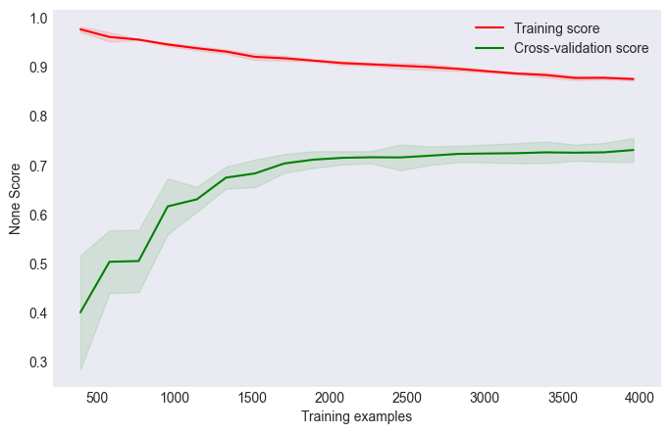

Figure 1. Learning Curve for GradientBooster

The best-performing model was identified through cross-validation and hyperparameter tuning.

Using the best-performing model the list of hotel guests that will generate the most revenue for the company is selected on the score set. This resulted in a estimated revenue of **466151.517** compared to the revenue from a random sample, which was **368176.875**. This means a gain of **97974.642** with respect to random sample. This indicates that targeting the selected list of hotel guests can potentially lead to increased revenue for the hotel.

This resulted in a gain with respect to a random sample of **97974.642** compared to the revenue from a random sample, which was **343,572.614**. This indicates that targeting the selected list of hotel guests can potentially lead to increased revenue for the hotel.

It is recommended that the hotel manager consider applying the selected list of hotel guests for tailored marketing strategies to capitalize on the potential revenue increase. By focusing efforts on these specific guests, the hotel can optimize its marketing initiatives and enhance overall profitability.